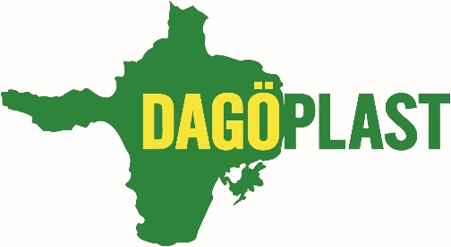
ISO 9001, ISO 14001 ja ISO 22000
Dagöplast AS is a company located in Estonia, on the island of Hiiumaa. The company was established in 1998 and our experience and competencies in the field of film and bag production have made us a strong and reliable partner for our suppliers and customers. We have Scandinavian organisational culture and good partnerships, which make it possible to provide our products to customers all over the world. At the same time, we are an important company and employer for the local community.
In our everyday operation we put a lot of focus on environmental matters and invest continuously in more sustainable solutions.
Below are some of the concrete steps we have taken towards a smaller environmental footprint:
Work environment | Product development
*Safety and security always in focus  *Only Green Energy used in all units  *Solar panels in operation on the roof of the main factory  *Led lights and motion sensors for saving energy are in use  *High focus put on product composition and environmental impact  *Digitalization of processes towards paperless factory  *Use of residual heat from production in warehouse and in workshops | *Cooperation with universities and other partners  *Testing and use of newest biodegradable and compostable materials  *Own laboratory with certified and calibrated equipment for ensuring the product compliance to the requirements  *Participation in green projects and conduction of relevant audits  *Making sustainable choices when it comes to (packaging) materials
Waste reduction | Education and local community
*Sorting and recycling our (production) waste  *Yearly investments in the machinery and operations to minimize the amount of waste  *Use of fully compostable raw materials  *Continuous improvement of efficiency and optimization of processes to create more value and less waste | *Continuous education of our employees and the local community about sustainability and sorting waste  *Providing constant support to the local community with events, products, and know-how about sustainability
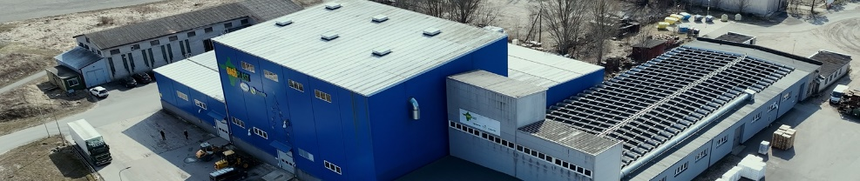
Kulvo Pendra
CEO
Dagöplast AS

